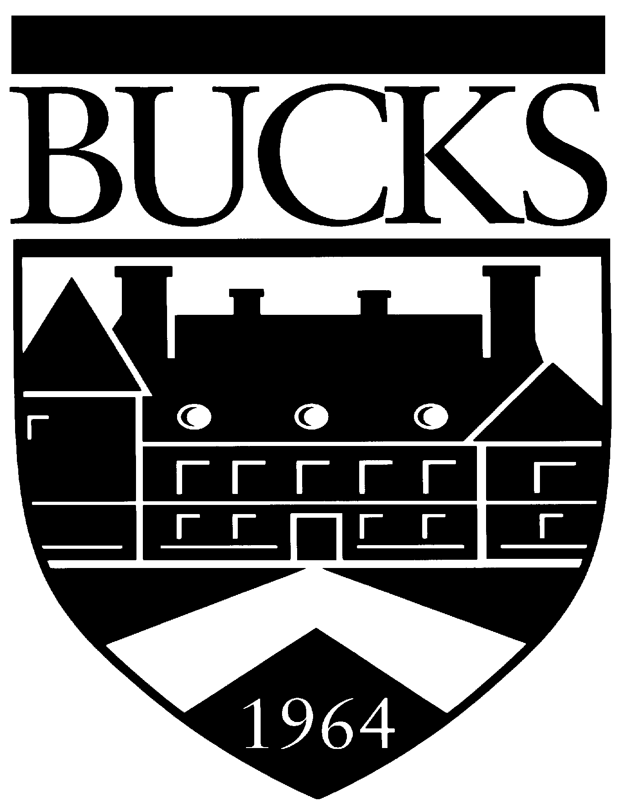 Bucks County Swamp Road Continuing Education
Community College Newtown, PA 18940 (215) 968-8409
Cultural Programming
(215) 968-8087

OFFICE OF CONTINUING EDUCATION

Course Proposal and Outline Form

Please complete and return this form to the Continuing Education Office for each course you wish to teach. If you have a particular preference for course dates, please indicate so. If your dates are flexible, please list preferred day of the week and month(s). We will contact you to confirm dates and times when your course is approved.

NAME OF COURSE:

Ages of Students (if children’s course)

Date(s):

Time:

Available to teach at following location(s): Newtown Bristol Upper County Off-site

NAME OF INSTRUCTOR: PHONE: (Work)
(Home)
Check if new address (Cell)
ADDRESS: EMAIL:

City, state, zip:

1. Is enrollment limited? If so, what is the limit?

2. Is there a materials fee for participants? If so, how much?

- List exact material participants will receive for this fee (Duplicated handouts may not be included; these are copied through

the Continuing Education Office.

4. Is a book required for the class? If yes, who is responsible for ordering?

Instructor (students will pay instructor directly)

Continuing Education (book fee will be included in course fee, or students will purchase from bookstore)

- List any special room, space or equipment/preference, and specific dates needed:

IMPORTANT: The State mandates that we have on file new Course Outlines each semester for each course offered. A photo copy of a previous syllabus form cannot be accepted. An updated resume must also accompany your proposal if you are a new instructor or have not submitted one within the past two (2) years. Keep a copy of these forms for your records.

THANK YOU! WE LOOK FORWARD TO YOUR PARTICIPATION!

For Office Use Only:

Course # __________________

Credit Type __________________

CEU’s __________________

Topic code __________________

AR Code __________________

Other Charges _______________
For Office Use Only:

Date Approved: ___________________________

Approval Signature: _____________________________

BUCKS COUNTY COMMUNTY COLLEGE

CONTINUING EDUCATION

Course Outline for Non-Credit Continuing Education Programs

Course Title:

Dates:

Name of Instructor:

Total Hours of Instruction: Total Lab Hours (if applicable):

Course Description/Summary:

Course Learning Outcomes (identifies knowledge and/or skills students can expect to acquire upon
completion of course – separate sheet may be attached, if necessary):

Course Topical Outline ( a planned sequence of topics or learning activities for each session designed to help
students achieve the learning outcomes – a separate sheet may be attached if necessary):

Reference, resource or learning materials to be used by students (includes text, audio/visuals, manuals, handouts,
art supplies, etc.):

BUCKS COUNTY COMMUNITY COLLEGE
CONTINUING EDUCATION OFFICE
TEXTBOOK REQUEST FORM

Please complete the following information if you wish students to purchase a workbook/textbook for your class. Books will be made available in the College Bookstore on or before the class start date unless otherwise arranged through this office. Please do not list supplementary reading material.

Course Name:

Instructor:

Book Title:

Author:

Name & Address of Publisher:

Phone Number of Publisher:

Paperback or Hardbound:

ISBN No.

Approximate Cost of Book:

Additional Comments:

Please return this form along with your Course Proposal Form and Syllabus.

Thank you.

