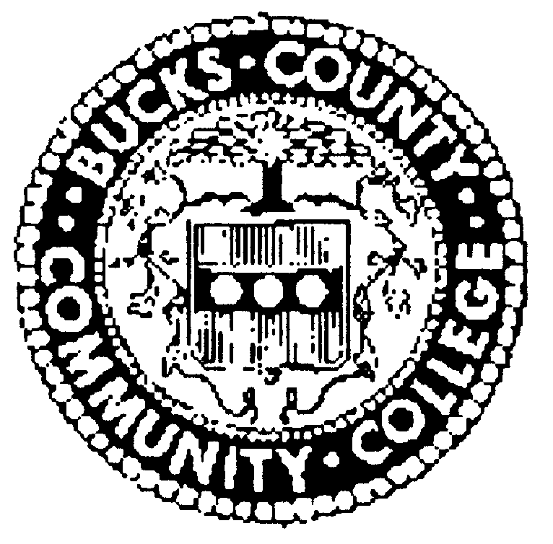
BUCKS COUNTY COMMUNITY COLLEGE

BOARD OF TRUSTEES MEETING

Upper Bucks Campus

Date: November 8, 2018
Time: 11 A.M.
________________________________________________________________________

PRESENT:

Elizabeth Fineburg, Presiding
David Breidinger
James Dancy
Blake Eisenhart,
Elizabeth Graver
Otto Grupp III
William Maeglin
Linda Mannherz
Carol Mignoni-Ferguson
Garney Morris
Thomas Skiffington
Philip Wursta
Jeffrey Garton, Esq.
Dr. Stephanie Shanblatt

ABSENT: Frank Fazzalore, Frank Farry, and Carol Shelly

Ms. Fineburg called the meeting to order at 11:05 AM and announced that earlier in the day the Board of Trustees met in executive session to discuss real estate, labor relations and personnel matters.

Upon motion by Mr.Morris, seconded by Mr. Skiffington, the board approved the minutes of the October meeting.

CHAIR’S REPORT

There was no report from the Chair.

PRESIDENT’S REPORT

The President reported that the fall athletic season was a great one for our teams. Men’s soccer closed the season with a 13-5 record, making it all the way to the Region XIX championship game. Individual honors were garnered by Prince Boafo as EPAC Player of the Year and Justin Burroughs who was named EPAC Coach of the Year. Seven other players were named either to All Conference or All Region teams.

Women’s soccer finished 13-4 and played for the region championship. Katie Crouthamel was named EPAC Player of the Year and three teammates were named to the All Region team. Volleyball racked up a 9-3 conference record with five players on All Conference or Region teams. Congratulations to all of our student athletes and special thanks to the staff of the Student Life and Athletics department who support the student athletes.

Dr. Shanblatt thanked all who were present on October 17 as the college joined with officials from the County to announce a partnership in a new building to be located at the Gene & Marlene Epstein Campus. The Bucks County Center for Economic & Workforce Development will house the college Center for Workforce Development, Bucks County Career Link, the Workforce Development Board, and the County of Bucks Economic Development offices.

President Shanblatt recognized the Women’s Summit on Entrepreneurship on October 26 at the Upper Bucks Campus. The summit featured four workshops and a lunch roundtable designed to benefit and inspire both women who are starting their businesses and those with established enterprises. Thanks to Dean Tracy Timby and her staff for organizing this great event.

Dr. Shanblatt shared news of two new appointments to the Foundation Board of Directors: community representative Dottie Fiedler of Washington Crossing along with Bucks student Shanzeh Khan who became the first student representative serving on the board as a voting member. Additionally, Christine Harvie, college In School Youth Program Coordinator and Bucks graduate, was appointed to the Alumni Council. Assistant Director, Foundation & Alumni Relations, Christina McGinley was a featured panelist at the Donor Perfect Community Network Conference.

The President ended her remarks with an overview of upcoming cultural events on campus include the following: Hicks Art Center Gallery presents the exhibit MATTER through December 10 and the Zlock PAC presents Rag Tag Theater’s “Cinderella” at 3 p.m. Saturday, November 10, at the Newtown campus. Also, be sure to check the college website for details on five free student performances from November 15 to December 16 featuring the Jazz Orchestra, Concert Choir, and several small-group ensembles. Finally, the Madrigal Singers will join Trinity Church Friends of Music choir and orchestra for Handel’s Messiah, 4 p.m. Sun. Dec. 16 at Trinity Episcopal Church in Solebury.

PUBLIC COMMENT

Professor John Straus noted that the new Bucks County Poet Laureate will be reading at the college on Sunday, November 18.

COMMITTEE REPORTS

ACADEMIC, STUDENT & TECHNOLOGY COMMITTEE – Carol Shelly, Chair

Jason Mayland, Vice President Technology and Innovation, presented a report on enrollment for Fall 2018. Four major drivers of enrollment in the county are all trending in a manner that contributes to the enrollment decline experienced over recent years. These drivers include total population, age distribution, annualized unemployment and public school enrollment.

The downward trend in both students and aggregate credits continued in Fall 2018, although less than in previous years, with the metrics decreasing by 1.74% and 1.71% respectively. By category of student, evening enrollments experienced the greatest decline. E-learning, Lower Bucks and community sites grew as market segments. The greatest growth demographically was in the 20-24 year age group.

Next Mr. Mayland reviewed data on financial aid utilization by students. While some volume indicators are trending downward, corresponding to decreases in enrollment, financial aid continues as a critical factor enabling many of our students to continue their educational pursuits. More than 70% of those enrolled receive some form of aid and 32.5% receive Pell funds. Totaling $16,496,620 during 2017-2018, the majority of financial aid dollars flow through federal funding with the balance coming from state, scholarships and institutional funds. The college continues to have one of the lowest student loan default rate of Pennsylvania’s fourteen community colleges.

Dr. Rodney Altemose, Executive Director UCC, provided an update on the Upper County campus including a pictorial recap of its history since 1999. The location offers a wide variety of programs in both credit and non-credit areas. Students are able to complete four programs at UBC, as well as all of their General Education course requirements. Non-credit programs available include practical nursing, nurse aide, GED prep, IT Academy and others.

Campus representatives and student groups are active in the community, collaborating with community groups such as Pennridge and Upper Bucks Chambers of Commerce, Sisters U, United Way of Bucks County and Adopt-a-Highway. Campus organizations offering the opportunity for co-curricular development include Teachers of Tomorrow, Community Volunteer Corps and Coalition for Christian Outreach. The campus also sponsors an annual trip and service project in conjunction with Habitat for Humanity.

CONSENT AGENDA – William D. Maeglin, Chair, Finance Committee

There were no items for approval on the Consent Agenda at this meeting.

BOARD COMMENTS

There were no board comments.

ADJOURN

Upon the motion being duly made and seconded, the meeting was adjourned at 11:50 AM. The next regularly scheduled meeting of the Board of Trustees will be on December 13, 2018 at
11 AM on the Newtown Campus.

______________________________________________Philip Wursta, Secretary

